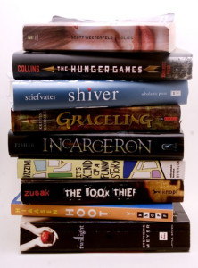
Summer Reading Book Sale
Hialeah Gardens Middle School
7th Grade Novels - 2019 -2020

Grade 7 ELA / Advanced - Novel Set Price $ 36
Summer Reading Novel: "The Great Fire” by Jim Murphy $13.99

Required Reading:
1st & 2nd Quarter: "The Outsiders” by S. E. Hinton $11.00
3rd & 4th Quarter: “This Was Then, This IS Now" S.E. Hinton $10.99

-------------------------------------------------------------------------------------------------------------------------------

Grade 7 ESOL - Novel Set Price $ 23 / $ 24

Summer Reading Novel:
ESOL Level 1 and 2 – “Charlotte’s Web” by E.B. White $9.99
ESOL Level 3 and 4 – “Flying Solo” by Ralph Fletcher $8.99

Required Reading:
1st & 2nd Quarter: “Among the Hidden” by Margaret Peterson Haddix $8.99
3rd & 4th Quarter: “A Christmas Carol” by Charles Dickens $4.99

