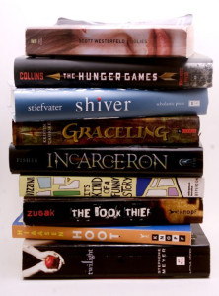
Summer Reading Book Sale
Hialeah Gardens Middle School
6th Grade Novels - 2019 -2020

Grade 6 ELA / Advanced - Novel Set Price $ 26

Summer Reading Novel: "Dear Dumb Diary: It's Not My Fault… " by J. Benton $7.99

Required Reading:
1st & 2nd Quarter: "Everything on a Waffle" by Polly Horvath $8.99
3rd & 4th Quarter: "Black Ships Before Troy” by Rosemary Sutcliff $8.99

-------------------------------------------------------------------------------------------------------------------------------
Grade 6 ESOL - Novel Set Price $ 26 / 27

Summer Reading Novel:
ESOL Level 1 and 2 – “Charlotte’s Web” by E.B. White $9.99
ESOL Level 3 and 4 – “Flying Solo” by Ralph Fletcher $8.99

Required Reading:
1st & 2nd Quarter: “Afternoon of the Elves” by Janet Taylor Lisle $8.99
3rd & 4th Quarter: “Freak the Mighty” by Rodman Philbrick $7.99

