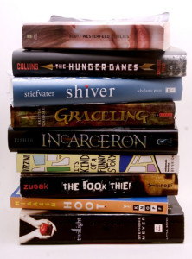
HGMS
2018-2019 Required Novels

Grade 8 ELA / Advanced
Summer Reading Novel: "The Wave" by Todd Strasser

Required Reading:
1st & 2nd Quarter: "Prisoner B3087" by Alan Gratz
3rd & 4th Quarter: "Murder on the Orient Express" by Agatha Christie

Grade 8 ESOL

Summer Reading Novel:
ESOL Level 1 and 2 – “Charlotte’s Web” by E.B. White
ESOL Level 3 and 4 – “Flying Solo” by Ralph Fletcher

Required Reading:
1st & 2nd Quarter: “Night” by Elie Wiesel
3rd & 4th Quarter: “Scorpions” by Walter Dean Myers

