HGMS 6th Grade – 2018 Summer Reading Project
“City of Ember” by Jeanne DuPrau

Novel Brochure
Due: September 28, 2018
Directions: Create a brochure about your book to show what you learned and catch the interest of another reader. Be creative, colorful, and informative. Use any type of 8 ½” X 11” paper. Use the template provided in Microsoft’s Word or Apple’s Pages to create the brochure. Glue both pages together (or print back to back) and then fold to create the brochure.

- Inside Left—“To Sum It Up”

  - Write a two-paragraph summary of your book
  - Use who, what, where, when, and why to summarize your book.

- Inside Middle—“What I Learned”

a) Write 5 interesting facts that you learned
b) OR write a life lesson the story taught you.

3) Inside Right—“What’s In a Picture”
a) Choose three images from the book or if there are no pictures, choose three interesting parts.
b) Draw the images/ picture for each interesting part & explain the significance of each illustration.

4) Flap—“A Few More Questions”
a) Write five questions you still have about the topic or a life lesson in the book.

5) Back —“In My Opinion”
a) Write your opinion of the book.
b) Express your views about the topic or life lesson discussed in the book.

6) Front Cover--Title/Author/Illustration
a) Write the title and author’s name on the front flap.
b) Create an original illustration that represents your book but is not from the cover of the book.

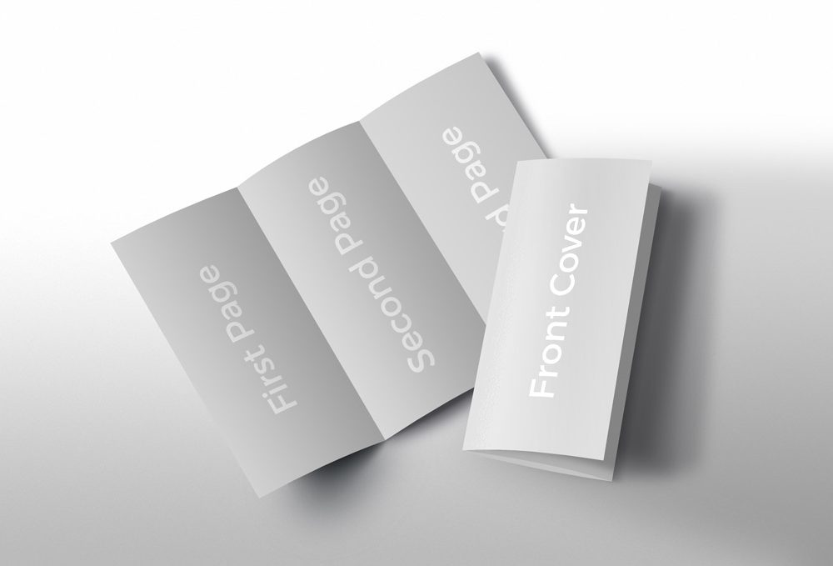

Front of the Brochure Inside of the Brochure
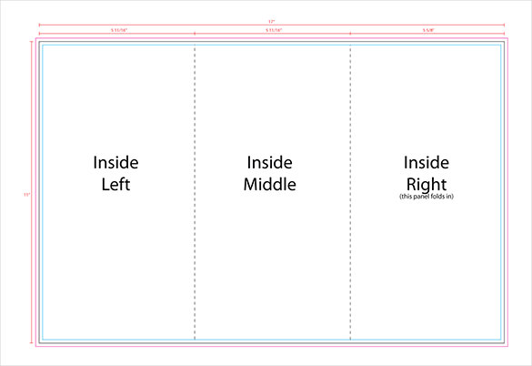
Front Cover
Back
Flap

After printing, fold the pages carefully to form the brochure

