2018 ESOL Summer Reading
Hialeah Gardens Middle School

ESOL Summer Reading Activities
Summer Reading book “Charlotte’s Web” by E. B. White ( ESOL level 1 and 2 students )
Summer Reading book “Flying Solo” by Ralph Fletcher ( ESOL level 3 and 4 students )

Project for ESOL 1-2
Create a timeline of the major events in your book. Use drawings or magazine cutouts to show the events along the timeline.
Time line example:
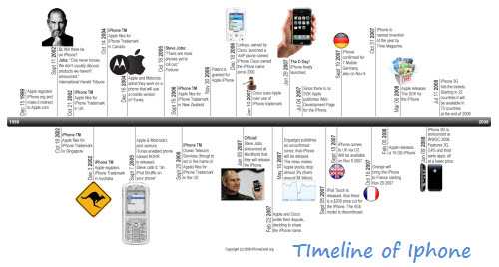

Rubric for the Timeline Project ESOL (1 and 2)

Category | A (100-90) | B (89-80) | C (79-70) | D (69-60)
Quality of content | Included events are important and interesting. No major details are excluded. The timeline includes 10 events or more. | Most of the events are important/relevant or interesting. The timeline contains 6-7 events. | Some events included are lacking importance and major events are missing. The timeline includes 5 events at least. | Missing many major events, and too many trivial ones are included. The timeline contains fewer than 5 events.
Sequence of content | Events are placed in proper order. | Almost all events are placed in proper order. | Half of the events are placed in proper order. | Most events are incorrectly placed on the timeline.
Mechanics | Punctuation, spelling and capitalization are correct throughout. | Punctuation, spelling and capitalization are mostly correct. | Project mostly lacks Punctuation, spelling, and capitalization. | There are many punctuation, spelling, and capitalization errors.

Project for ESOL Level 3-4

Use drawings or magazine cutouts to portrait the main character and write a summary to accompany your sketch.

Design a small poster to advertise your book. Be creative…use details…elaborate…use color! Try to make it 3-D or movable (optional).

Rubric for the Poster project ESOL 3 & 4

Category | A (100-90) | B (89-80) | C (79-70) | D (69-60)
Required Elements | The poster includes all required elements as well as additional information. The overall purpose  of the summary is  clear. | All required elements are included on the poster. The purpose is generally  Clear but missing details. | All but 1 of the required elements is included on the poster. The summary does not accurately express the main idea or most  major points. | Several required elements were missing. The summary does not  convey the main idea or major points of the original selection;
Attractiveness | The poster is exceptionally attractive in terms of design, layout, and neatness. | The poster is attractive in terms of design, layout and neatness. | The poster is acceptably attractive though it may be a bit messy. | The poster is distractingly messy or very poorly designed. It is not attractive.
Grammar | There are no grammatical mistakes on the poster. | There is 1 grammatical mistake on the poster. | There are 2 grammatical mistakes on the poster. | There are more than 2 grammatical mistakes on the poster.

