HGMS 7th Grade – 2019 Summer Reading Project
“The Great Fire” by Jim Murphy

Novel Brochure
Due: September 27, 2019
Directions: Create a brochure about your book to show what you learned and catch the interest of another reader. Be creative, colorful, and informative. Use any type of 8 ½” X 11” paper. Use the template provided in Microsoft’s Word or Apple’s Pages to create the brochure. Glue both pages together (or print back to back) and then fold to create the brochure.

- Inside Left—“To Sum It Up”

  - Write a one paragraph summary of your book
Use who, what, where, when, and why to summarize your book.

- Inside Middle—“What I Learned”

a) Write 3 interesting facts that you learned
b) OR write a life lesson the story taught you.

3) Inside Right—“What’s In a Picture”
a) Choose two image from the book or if there are no pictures, choose two interesting parts.
Draw the images/ picture for each interesting part & explain the significance of each illustration.

4) Flap—“A Few More Questions”
a) Write three questions you still have about the topic or a life lesson in the book.

5) Back —“In My Opinion”
a) Write your opinion of the book.
Express your views about the topic or life lesson discussed in the book.

6) Front Cover--Title/Author/Illustration
a) Write the title and author’s name on the front flap.
Create an original illustration that represents your book but is not from the cover of the book.

Front of the Brochure Inside of the Brochure
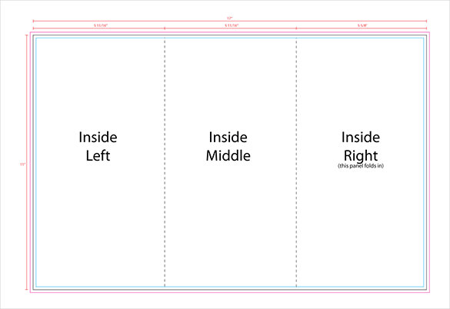
Front Cover
Back
Flap

After printing, fold the pages carefully to form the brochure

HGMS 7th Grade – 2019 Summer Reading Project
“The Great Fire” by Jim Murphy

Vocabulary Practice Activity
Due: September 27, 2019

As part of your Summer Reading assignment, you will have to complete a vocabulary practice lesson using words from your summer reading novel. Highlight the words in your novel as you complete the practice lesson. To join the class or to create your account, follow the instructions on the flyer below.

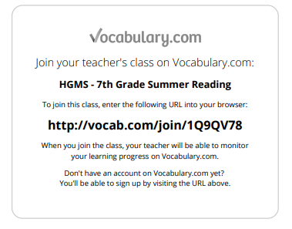

If you are creating a new account, please use the following for user name and password
USER NAME: firstlastname
PASSWORD: ID #

