HGMS 7th Grade – 2018 Summer Reading Project
“Jacob’s Rescue” by M. Drucker & M. Halperin

Project # 1 - Brochure (50 points)
Directions: Create a brochure about your book to show what you learned and catch the interest of another reader. Be creative, colorful, and informative. Use any type of 8 ½” X 11” paper. Use the template provided in Microsoft’s Word or Apple’s Pages to create the brochure. Glue both pages together (or print back to back) and then fold to create the brochure.

- Inside Left—“To Sum It Up”

  - Write a one paragraph summary of your book
  - Use who, what, where, when, and why to summarize your book.

- Inside Middle—“What I Learned”

a) Write 3 interesting facts that you learned
b) OR write a life lesson the story taught you.

3) Inside Right—“What’s In a Picture”
a) Choose two image from the book or if there are no pictures, choose two interesting parts.
b) Draw the images/ picture for each interesting part & explain the significance of each illustration.

4) Flap—“A Few More Questions”
a) Write three questions you still have about the topic or a life lesson in the book.

5) Back —“In My Opinion”
a) Write your opinion of the book.
b) Express your views about the topic or life lesson discussed in the book.

6) Front Cover--Title/Author/Illustration
a) Write the title and author’s name on the front flap.
b) Create an original illustration that represents your book but is not from the cover of the book.

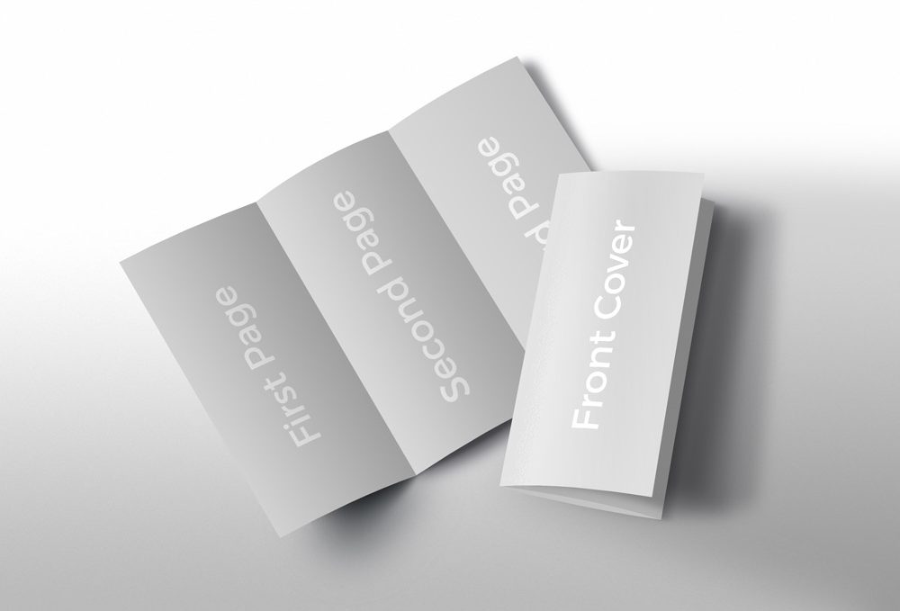

Front of the Brochure Inside of the Brochure
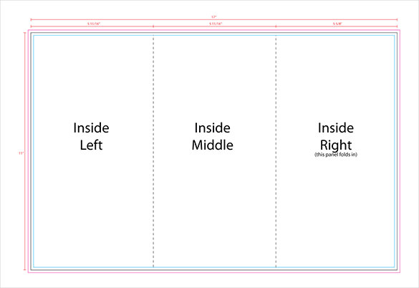
Front Cover
Back
Flap

After printing, fold the pages carefully to form the brochure

HGMS 7th Grade – 2018 Summer Reading Project
“Jacob’s Rescue” by M. Drucker & M. Halperin

Project # 2 – “One Pager” (50 points)
What is a One-Pager? It is a single-page response to your reading. It connects the ideas in the book to your thoughts in a creative way. You will create your One-Pager so your audience will understand the big ideas, themes, or connections within the book you read.

Directions: Your One-Pager needs to be on an 8.5 x 11-inch sheet of white copy paper. A multimedia/digital one-pager may be created as long as the same requirements are met. The writing must be legible. The One-Pager should be visually appealing and organized.

1. Write the title of the book, correctly punctuated, along with the author’s name on the page.
2. Select three interesting and important passages or sentences from the book. Write them on the page with quotation marks around them. Include the page where the quote was found. If this is a line of dialogue from a character, include the character’s name after the quote. Write these in one color.
3. Write three personal statements about what you have read. These are not simple opinions about the content of the material (for example: it was funny or it was boring), but meaningful statements about what you have read. (For example: I could relate to main character feeling confused, because I felt the same way when I moved to a new school.) Write these in a second color.
4. Write three meaningful questions about the book. (For example: What does it mean when Carl refuses Anthony’s friendship?) Write these in a third color.
5. Answer your three questions with complete sentences. (For example: Carl refuses Anthony’s friendship because he wants to be independent.) Write these in a fourth color.
6. Draw or create three images that represent themes, characters, conflict, or setting in the book you are reading. It is important that the visuals have strong connections to the book.
7. Include a key or legend on the back of the One-Pager indicating what each color represents and explain what your pictures symbolize.

Helpful hints:
• Use paper without lines to allow your work to stand out.
• Use the entire page; make it rich with words and images.
• Either hand-write or computer generate your One-Pager, but be consistent.
• Make your work easy to read, polished, and representative of your best effort

