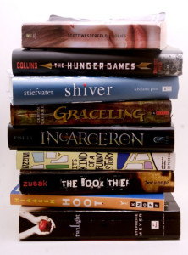
Summer Reading Book Sale
Hialeah Gardens Middle School
8th Grade Novels - 2019 -2020

Grade 8 ELA / Advanced - Novel Set Price $ 46
Summer Reading Novel: "Artemis Fowl" by Eoin Colfer $9.99

Required Reading:
1st & 2nd Quarter: "Prisoner B3087" by Alan Gratz $17.99
3rd & 4th Quarter: "Refugee" by Alan Gratz $17.99
-------------------------------------------------------------------------------------------------------------------------------

Grade 8 ESOL - Novel Set Price $ 30 / $ 32

Summer Reading Novel:
ESOL Level 1 and 2 – “Charlotte’s Web” by E.B. White $9.99
ESOL Level 3 and 4 – “Flying Solo” by Ralph Fletcher $8.99

Required Reading:
1st & 2nd Quarter: “Night” by Elie Wiesel $10.95
3rd & 4th Quarter: “Scorpions” by Walter Dean Myers $9.99

